October | 2020
Sunday | Monday | Tuesday | Wednesday | Thursday | Friday | Saturday
 |  |  |  | 1 | 2 | 3
 |  |  |  |  | Walk-A-Thon @ CLS | CLS Golf Outing
CLS @ Martini 4 | 5 | 6 | 7 | 8 | 9 | 10
Heritage 8:30am  Bible classes 9:45  Contemp: 10:45 | Staff Meeting 9:00am | Kids Club Chapel:  9: 30 | Catechism 4:30pm  Night Service 6:30pm  Choir 7:30pm |  |  | St. Paul Gar Creek Fish Fry
11 | 12 | 13 | 14 | 15 | 16 | 17
Heritage 8:30am  Bible classes 9:45  Contemp: 10:45 | Staff Meeting 9:00am | Kids Club Chapel:  9: 30 | Pastor @ CLS Chapel  Catechism 4:30pm  Night Service 6:30pm  Choir 7:30pm | CLS School Board Meeting
18 | 19 | 20 | 21 | 22 | 23 | 24
Heritage 8:30am  Bible classes 9:45  Contemp: 10:45 | Staff Meeting 9:00am  CLS Picture  Re-take Day  Pastor Conference | Kids Club Chapel:  9: 30  Pastor Conference | Catechism 4:30pm  Night Service 6:30pm  Choir 7:30pm  Pastor Conference
25 | 26 | 27 | 28 | 29 | 30 | 31
Heritage 8:30am  Bible classes 9:45  Contemp: 10:45 | Staff Meeting 9:00am | Kids Club Chapel:  9: 30  Stewardship and finance 7:00pm | Catechism 4:30pm  Night Service 6:30pm  Choir 7:30pm |  | No School CLS | 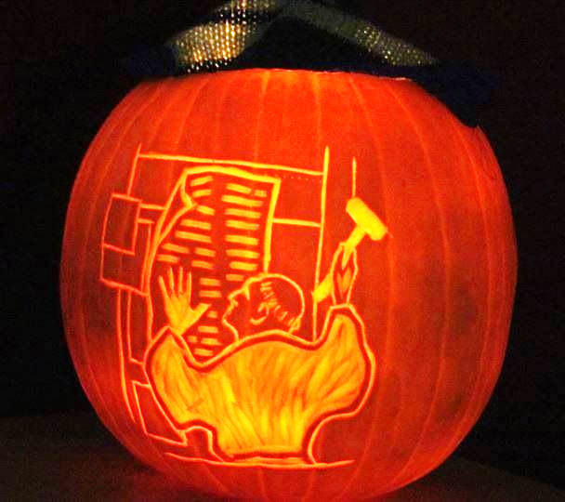  Reformation Day  Halloween

