Martini Lutheran
Church
 | March | 2020
 | 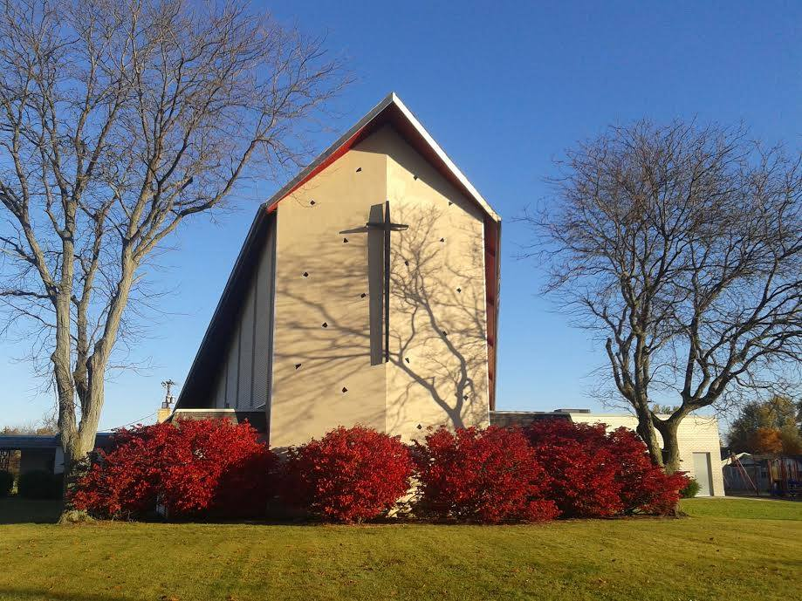 |  |  |  |  | Youth Group  March 8th, please join us @ CLS for some Dodge Ball/Open Gym. Please bring a friend.
Lent
Join us Wednesday nights for dinner throughout the Lenten Season.
Dinner starts at 5:30pm Service starts at 6:30pm

 | Our Services
Erica Ernest 25th Anniversay
in Lutheran Education
 | We are blessed to have Erica Ernest as part of our CLS faculty and are excited to celebrate her 25th anniversary in the teaching ministry!  We will be celebrating on Thursday, March 19, with an evening concert by Jennie Williamson of Arison records.  The concert is a free event and will begin at 6 p.m. in the main gym with a cake reception to follow. |  |  |  | This is going to be a great evening where we can give thanks to God for Mrs. Ernest's service, and both children and adults will be encouraged by Jennie Williamson's music.  Please make plans to attend. | Bible Study  Mens bible study meets on the first and third Monday of every month at 7:00PM  Womens bible study meets on the secon and fourth Tuesday of every month at 7:00PM

March | 2020
Ash Wednesday is February 26th, 2020. Dinner is at 5:30 pm and Service will start at 6:30pm. Everyone is welcome. This is a communion service and ashes will be distributed as well. Dinner will be a potato bar severed by our Martini Church Council.

¹⁷ The Lord your God is in your midst, a mighty one who will save; he will rejoice over you with gladness; he will quiet you by his love;
he will exult over you with loud singing.
- Zephaniah 3:17

Upcoming Events:
01  March 1st Central Assosiation Meeting CLS @ 1:00pm |  |  | 08  Daylights Saving Time March 8th, Spring Forward!
08  Youth Group Dodge ball and open gym! |  |  | 19  Erica Ernest 25th Anniversary of Lutheran Education.

