Martini Lutheran Church

May 2021

Congratulation to this year’s Confirmands:
Nico Conley and Preston Moore

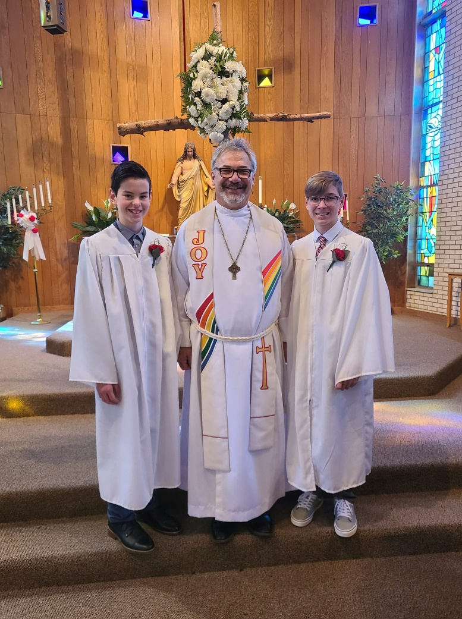

'How Do We Help People Believe in Christ - Through Martini'
At the beginning of April, those who selected on How Do We Help People Believe in Christ through Martini came together for a brainstorming meeting. From these meetings several choices were selected to start to work towards helping people believe in Christ:
- Name Tags - You'll find in your Church mailbox your personalized Name Tag. Feel free to wear them during worship services. And if you choose to, you may keep them in your mailbox for the next service.
- Door Greeters - We are working on a sign-up sheet to gage participation
- Sign Messages - We are working on a sign-up, along with instructions & message ideas
- Outdoor Worship Service - We are pleased to announce that we will have an Outdoor Worship Service on June 6, 2021. This will be one service at 10:00am. Please bring a lawn chair if you would like, we will have additional chairs available at the church. We ask you to please pray that the weather will cooperate with our worship efforts. More details will be coming soon!
This is just the start. We need to keep the momentum going! First, should we continue to meet to discuss making these first steps a success between services or another day / evening? Second, we need everyone's help to
make these ideas a success. So please, sign up to help & participate in one or more of the above ways. Lastly, thank you for attending the meetings & bringing great ideas & feedback! It was inspiring to see us come together as a Church family to continue to help people believe in Christ!
Mother's Day Bake Sale Fundraiser:
It's back! The Fundraising Committee will be making desserts for Mother's Day again this year, and it will be Pre-Order ONLY. Please sign up for a cake or pie on the signup sheet located on the bulletin board in the fellowship hall. You may also call Sara in the office at 260-749-0014 or Lizzie at 260-557-3167 to order a dessert. All orders must be in by Friday, May 7th. These are homemade desserts and we will be accepting a free will offering as payment. You may pick up your dessert in the fellowship hall Sunday, May 9th between the church services. If you have any questions, please ask either Sara or Lizzie so that we can help. We would love for every mother to have a dessert for Mother's Day. Happy Mother's Day!!

The Family Education Board is UP and ready for you to stuff an envelope! Checks can be made out to Martini Lutheran Church, please right money board in the memo.

Kids Club News:
The Board of Education’s has approved to let us have volunteers at Martini Kids Club. Volunteers will only be allowed to help out for 8 hours or less a month and will be asked to read, play music, do crafts with kids, and occasionally hold a baby. If you would like more information, please call the office and ask for Sara or Morgan, or email us at martinikidsclubministry@gmail.com

Central Lutheran School and Preschool
Blessings to All
CENTRAL LUTHERAN SCHOOL BUILDING FUND UPDATE

“CLOSE THE GAP CAMPAIGN”

Brothers and Sisters in Christ at Martini,
As you know the capital campaign continues and an approximate $1.3M debt remains that will come due in September of this year. The “Close the Gap Campaign” is now underway to retire this dept by September. We need help from everyone to achieve this goal and finish what we started and committed to so that we can continue to work to keep Christ centered education at Central Lutheran as cost effective as possible for the children and families at Central Lutheran. We will begin reaching out to
our church and CLS families to seek pledges and contributions. Please pray on the matter and let the Love of our Risen Lord and Savior Jesus Christ guide your heart. Principal John Weber and I will be open to meeting with you via phone, video conference or in person if you are comfortable. If you would like to set up a meeting please reach out to either of use at the contact information provided.
Troy Smith: email troysmith@indianapt.com and cell 260/385-8756
John Weber: email jweber@cluth.org and cell 260/246-9309
In Christ, Troy Smith
Association Meeting on Sunday, May 23 at 4 PM.

Stewardship Chat: “And God is able to give you more than you need, so that you will always have all you need for yourselves and more than enough for every good cause.” ~ 2 Corinthians 9:8

