Martini Lutheran Church

April 2022

Single Service Notes
On January 2nd, 2022 we moved to ONE Worship Service on Sunday mornings. Worship is at 9:00am with Communion on the ODD Sundays (1st, 3rd, & 5th).

Adult Bible Class and Sunday School is held 15 minutes after service ends.

Easter Egg hunt for Family and Friends of Martini Church and Kids Club Saturday, April 16th from 1:00pm-3:00pm

will have 2 egg hunts this year. One on the Saturday before Easter for the community and Martini Kids Club families. Saturday, April 16th from 1:00pm-3:00pm with a large egg hunt, crafts, cookie decorating and more. “Drop it like it’s TOT” food truck will be serving lunch. There WILL still have an egg hunt after the breakfast on Easter Sunday before 2nd service.

Easter Breakfast April 17th, 2022 following 7:0oam Service

Everyone is welcome to enjoy an Easter breakfast of pancakes, sausage, fruit, and coffee cake April 17 at 8:00am after the first church service. If you would like to donate a coffee cake, please let Lizzie Thomas know. We hope to see everyone there!

Central Lutheran Principal Call Committee
The Committee presented their recommendation for the position of principal and the Association voted to extend the call to Dave Van Spankeren. Mr. Van Spankreen has accepted the call.

A Concert of Brass & Organ Music Sunday, March 27, at 3 p.m.
Any graduate of Central Lutheran School who is planning on attending a Concordia University for the purpose of studying in the areas of Lutheran ministry may apply for our scholarship from CLS. Students studying to be pastors, teachers, DCE’s, Deaconess, and other ministry related positions may apply. Applications can be picked up in the school office and must be returned by Monday, May 2, 2022. You must be a graduate of CLS.

Have you considered giving a gift to the Concordia University Scholarship at CLS? Donations are accepted at any time. They can be given in memory of loved ones or in thankfulness for present teachers and pastors. Your gift will be used to encourage our brightest students to enter professions in Lutheran ministry. The scholarship helps to reduce the costs of attending a Concordia University. Presently, we will have a scholarship for Bethany Zeckzer, Kathryn Castens, Alexa Hoover, Callie Hoover, Paige Rebber, Blaire Rebber, and Caleb Zeckzer. Abby Wietfeldt, Amber Birkmire, and Anna Werling are currently teaching in our Lutheran schools and Bryan Stecker is a pastor. Derek Carey will be entering the Fort Wayne Seminary for his next 4 years. This year’s recipients will include Lizzie Gatchell, Grace Harmon, and Nathan Zeckzer. This list of students is amazing!! Please consider a gift in the coming months as we prepare to award next year’s scholarships. Keep these students in your prayers as they become the next generation of Lutheran educators. If you have any questions, please call Phyllis Hockemeyer, Mary Potter, Jon Bolt, or Rebecca VanSpankeren.

Gala 2022
GALA - Amanda Jones has volunteered to coordinate the Gala once again this year. Tiffany Herman has also volunteered to help plan and organize the event. If you know of anyone who would be a good addition to this team, please share their name with Amanda. This year’s Gala will be held on April 23rd with a theme of
Je T'aime, Central. Let’s spread the love!

If you are a Thrivent Financial member, please remember to designate your giving to Martini Lutheran Church. You can go online at https://www.thrivent.com/ or call (260) 442-3609 to speak to a representative.

Kids Club News:
Kids Club is in need of new bibs, burb rags, crib sheets along with toys such as barbies, action figures, dress up clothes, and card games. If you are interested, or know anyone who would be interested in child care or before and after school care please let us know. If you, or someone you know is pregnant and will need child care for their infant, please have them get on the waiting list as soon as possible. If you would like to make a monetary donation, please email us at: martinikidsclubministry@gmail.com

Here are a few photos of our Martini kid’s club activities this past month. March was full of new learnings as we moved infants that turned one into our transition room and had some of our older transition children move up to their next classroom. In the pictures below, you will see some of our newly one-year old’s sitting at a small table for the first time. You will also see a room 2 friend show a new friend who has moved up to the next room her favorite book.

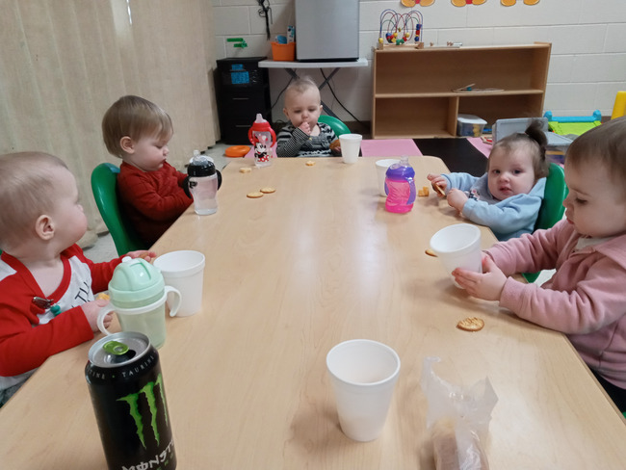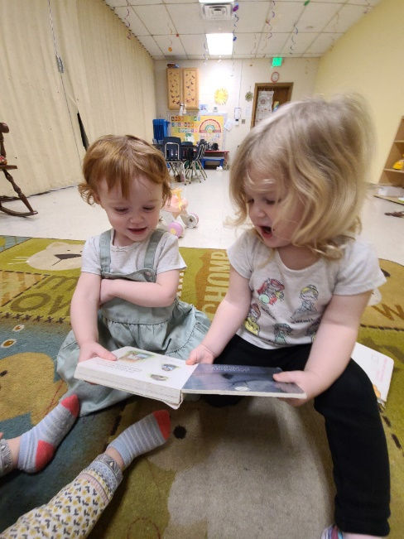

Wednesday Night services will start at 6:30pm with NO meal prior

4-06-2022 Jesus and God’s Wrath John 3:16,17, 36
Wrath is very intense anger, the kind of anger that does harm to the one, one is angry. God is right to be angry at us for rebelling against him and his anger is intense even wrath-filled. Rather than harm us by throwing us into hell thereby giving us over to the one we naturally prefer, He loves us and uses his Son Jesus Christ to rightly save us from his wrath. How did God save us? He punished Jesus, his Son, in our place.

4-14-2022 Jesus and his Body and Blood Mark 14:22-25
Tonight is Maundy Thursday. It is the night in our Church Year we set aside to remember our Lord’s betrayal and the institution of the Lord’s Supper. Jesus is God made man to suffer and die in our place to save us from God’s wrath. He even gave us his crucified body and blood to forgive us.

4-15-2022 Jesus and Redemption Matthew 20:28; 27:46
In Leviticus 16:10 God placed the guilt of Israel upon a scapegoat that was sent into the wilderness. See God’s use of a substitute? According to Matthew, Jesus of Nazareth, described his greatness in terms of being God’s substitute for us. His death was required to give us life eternal.

4-17-2022 Jesus and the Resurrection John 20:1-18
Today is Easter Sunday. The people who followed Jesus on that day were not very different from those of us who follow him today. On that day some women were determined to serve Jesus by embalming his dead body but he wasn’t dead. He had risen! Today we have some women so determined to serve Jesus in ways he does not need or want to served. On that day some men heard the good news Jesus has risen but they concluded the good news was only and “idle tale (Luke 24:11).” Today we have some men who will not learn God’s Word. Yet Jesus has risen from the dead and he teaches both our women and our men God’s will so we can believe and serve accordingly.

